浙江大学信息与电子工程学院 | 集成电路原理与设计 | 2023年10月
2023-2024学年春夏学期 | 集成电路原理与设计 | 2023年10月

Exercise 2
- The circuit shown in Fig.2.1 illustrates a single-channel MOS resistor with a W/L of 2μm/2μm. Using Table.2.1 model parameters calculate the small-signal on resistance of the MOS transistor at various values for VS and fill in the table below. (Note that the transistor was in linear region, VB=0, I_{DS}=0)
V_{S}(V) | R(Ω)
0.0
1.0
2.0
3.0
4.0
5.0
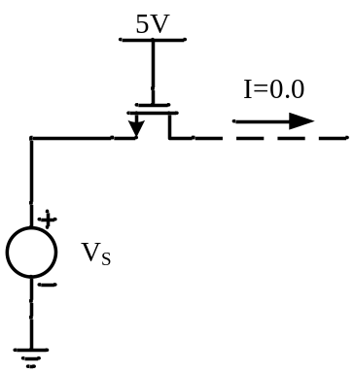
Fig.2. 1

Answer

The equation for threshold voltage is represented with absolute values so that it can be applied to n-channel or p-channel transistors without confusion.

$$\left|V_{T}\right|=\left|V_{T0}\right|+γ[\sqrt{2\left|Φ_{F}\right|+\left|V_{SB}\right|}-\sqrt{2\left|Φ_{F}\right|}]$$

$$r_{on}=\frac{1}{∂I_{D}/∂V_{DS}}=\frac{L}{KW(\left|V_{GS}\right|-\left|V_{T}\right|-\left|V_{DS}\right|)}$$

For n-channel device

$V_{T0}=0.7$ $γ=0.45$ $2\left|Φ_{F}\right|=0.9$ $K=134$
- When $V_{S}=0$,$V_{GS}=5$and $V_{SB}=0$

$$\left|V_{T}\right|=\left|V_{T0}\right|+γ[\sqrt{2\left|Φ_{F}\right|+\left|V_{SB}\right|}-\sqrt{2\left|Φ_{F}\right|}]=0.7$$

$$r_{on}=\frac{1}{∂I_{D}/∂V_{DS}}=\frac{L}{KW(\left|V_{GS}\right|-\left|V_{T}\right|-\left|V_{DS}\right|)}=1.736KΩ$$
- When $V_{S}=1$,$V_{GS}=4$and $V_{SB}=1$

$$\left|V_{T}\right|=\left|V_{T0}\right|+γ[\sqrt{2\left|Φ_{F}\right|+\left|V_{SB}\right|}-\sqrt{2\left|Φ_{F}\right|}]=0.893$$

$$r_{on}=\frac{1}{∂I_{D}/∂V_{DS}}=\frac{L}{KW(\left|V_{GS}\right|-\left|V_{T}\right|-\left|V_{DS}\right|)}=2.402KΩ$$
- When $V_{S}=2$,$V_{GS}=3$and $V_{SB}=2$

$$\left|V_{T}\right|=\left|V_{T0}\right|+γ[\sqrt{2\left|Φ_{F}\right|+\left|V_{SB}\right|}-\sqrt{2\left|Φ_{F}\right|}]=1.039$$

$$r_{on}=\frac{1}{∂I_{D}/∂V_{DS}}=\frac{L}{KW(\left|V_{GS}\right|-\left|V_{T}\right|-\left|V_{DS}\right|)}=3.806KΩ$$
- When $V_{S}=3$,$V_{GS}=2$and $V_{SB}=3$

$$\left|V_{T}\right|=\left|V_{T0}\right|+γ[\sqrt{2\left|Φ_{F}\right|+\left|V_{SB}\right|}-\sqrt{2\left|Φ_{F}\right|}]=1.162$$

$$r_{on}=\frac{1}{∂I_{D}/∂V_{DS}}=\frac{L}{KW(\left|V_{GS}\right|-\left|V_{T}\right|-\left|V_{DS}\right|)}=8.905KΩ$$
- When $V_{S}=4$,$V_{GS}=1$and $V_{SB}=4$

$$\left|V_{T}\right|=\left|V_{T0}\right|+γ[\sqrt{2\left|Φ_{F}\right|+\left|V_{SB}\right|}-\sqrt{2\left|Φ_{F}\right|}]=1.269$$

$V_{GS}<V_{T}$ The device is cutoff, so $r_{on}=\text{infinity}$
- When $V_{S}=5$,$V_{GS}=0$and $V_{SB}=5$

The device is cutoff, so $r_{on}=\text{infinity}$
V_{S}(V) | R(Ω)
0.0 | 1.736K
1.0 | 2.402K
2.0 | 3.806K
3.0 | 8.905K
4.0 | infinity
5.0 | infinity

- An NMOS with W=50μm and L=0.5μm operates in the saturated region and its layout is folded shown as Fig2.2. Calculate the all capacitances by using the parameters in Table2.2 and C_{ox}=3.8×10⁻³ F/m, V_{R}=0.6V. Assume that the minimum size (lateral) of S/D region is 1.5μm
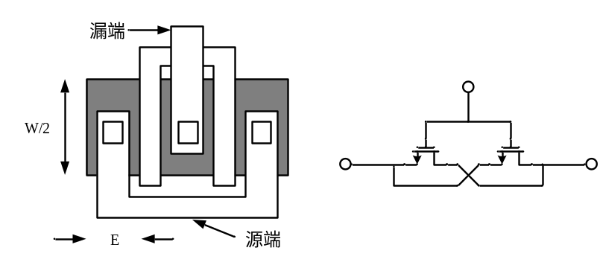
Fig.2. 2

Answer:
$$C_{j0}=0.56×\frac{10^{-3}F}{m^{2}},C_{jsw0}=0.35×\frac{10^{-11}F}{m},m_{j}=0.45,m_{jsw}=0.2 \\ C_{ov}=0.4×\frac{10^{-9}F}{m},W=50μm,L=0.5μm,L_{D}=0.08μm,E=1.5μm$$
$$V_{R}=0.6V,2Φ_{F}=0.9V,C_{ox}=3.8×10^{-3}F/m^{2},P_{SUB}=9×10^{8}m^{-3} \\ ε_{si}=11.7×8.85×10^{-12}F/m,q=1.6×10^{-19}C$$
$$C_{j}=\frac{C_{j0}}{(1+V_{R}/2Φ_{F})^{m_{j}}}\text{=}\text{0.445 }\text{fF/}{μm}^{2} C_{jsw}=\frac{C_{jsw0}}{(1+V_{R}/2Φ_{F})^{m_{jsw}}}=3.16×\frac{{10}^{-3}fF}{μm}$$$L_{eff}=L-2L_{D}\text{=0.34 }\text{μ}\text{m} C_{d}=WL_{eff}\sqrt{qε_{si}P_{SUB}/4Φ_{F}}$=$1.55×{10}^{-6}fF$
$$C_{DB}=\frac{W}{2}EC_{j}+2(\frac{W}{2}+E)C_{jsw}=16.85fF \\ C_{SB}=2(\frac{W}{2}EC_{j}+2(\frac{W}{2}+E)C_{jsw})=33.71fF \\ C_{GD}=2(\frac{W}{2}C_{ov})=20.0fF \\ C_{GS}=\frac{2}{3}WL_{eff}C_{ox}+WC_{ov}=63fF$$
$$C_{GB}=\frac{W{L_{eff}C}_{OX}C_{d}}{(WL_{eff}C_{ox}+C_{d})}=1.55×{10}^{-6}fF$$
- There is an N-type current source, I_{D} is 0.5mA, and the drain-source voltage V_{DS} must more than 0.4V when it works as a current source. If the minimum output resistance is 20 KΩ, determine the length and width of the device by using the parameters in Table.2.2.

Answer:
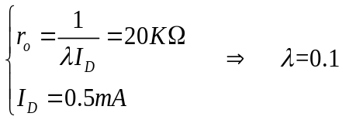
From the table2.2, L can be determined as L=0.5um.(
Calculating W
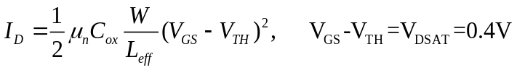
$$\frac{W}{L_{eff}}=\frac{I_{D}}{\frac{1}{2}μ_{n}C_{ox}(V_{GS}-V_{TH})^{2}}=\frac{0.5×10^{-3}}{\frac{1}{2}×134×{10}^{-6}×0.4^{2}}=46.64$$
$$∴ W=46.64L_{eff}=15.86μm$$

- A “ring” MOS structure is shown in Fig.2.3. Explain how the device operations and estimate its equivalent aspect ratio. Calculate the drain junction capacitance of the structure. (use Cj and Cjsw)
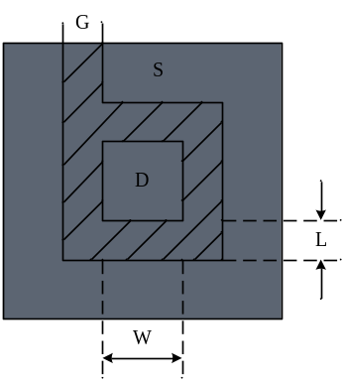
Fig.2. 3
Answer:
Width/length ratio is 4W/L
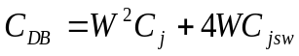

- Find the small-signal model (g_{m}, g_{mb}, g_{ds}) for an n-channel transistor with the drain at 4 V, gate at 4 V, source at 2 V, and the bulk at 0 V. Assume the model parameters from Table.2.1, and W/L = 10 μm/1 μm.
Answer:
$$V_{T}=V_{T0}+γ\left[\sqrt{2\left|Φ_{F}\right|+v_{SB}}-\sqrt{2\left|Φ_{F}\right|}\right] \\ V_{T}=0.7+0.45\left[\sqrt{0.9+2.0}-\sqrt{0.9}\right]=1.04 V \\ I_{D}=\frac{K'W}{L}(v_{GS}-v_{T})^{2}(1+λv_{DS}) \\ I_{D}=134×10^{-6}×10×(2-1.04)^{2}(1+0.1×2)=1482×10^{-6} A \\ g_{m}=\sqrt{4\frac{KW}{L}I_{D}} \\ g_{m}=\sqrt{4×134×10^{-6}×10×1482×10^{-6}}=2.818×10^{-3} S \\ g_{mb}=g_{m}\frac{γ}{2(2\left|Φ_{F}\right|+V_{SB})^{\frac{1}{2}}} \\ g_{mb}=2.818×10^{-3}\frac{0.45}{2(0.9+2.0)^{\frac{1}{2}}}=372.3×10^{-6} S \\ g_{ds}=\frac{λI_{D}}{1+λV_{DS}} \\ g_{ds}=1482×10^{-6}×0.1÷1.2=123.5×10^{-6} S$$

Table.2. 1
Typical Parameter Value
Parameter Symbol | Parameter Description | n-Channel | p-Channel | Units
V_{T0} | Threshold voltage(V_{BS}=0) | 0.7 | -0.8 | V
K | Transconductance parameter(in saturation) | 134 | 50 | μA/V²
γ | Bulk threshold parameter | 0.45 | 0.4 | V^{1/2}
λ | Channel length modulation parameter | 0.1 | 0.2 | V⁻¹
2|ϕ_{F}| | Surface potential at strong inversion | 0.9 | 0.8 | V

*$K'=\frac{1}{2}μC_{ox}$

Table.2.2
NMOS Model
LEVEL=1 | VTO=0.7 | GAMMA=0.45 | PHI=0.9
PSUB=9e+14 | LD=0.08e-6 | UO=350 | LAMBDA=0.1
TOX=9e-9 | PB=0.9 | CJ=0.56e-3 | CJSW=0.35e-11
MJ=0.45 | MJSW=0.2 | CGDO=0.4e-9 | JS=1.0e-8
PMOS Model
LEVEL=1 | VTO=-0.8 | GAMMA=0.4 | PHI=0.8
PSUB=5e+14 | LD=0.09e-6 | UO=100 | LAMBDA=0.2
TOX=9e-9 | PB=0.9 | CJ=0.94e-3 | CJSW=0.32e-11
MJ=0.5 | MJSW=0.3 | CGDO=0.3e-9 | JS=0.5e-8

上表给出的是0.5μm工艺level 1 MOS SPICE 模型参数的典型值，其中的参数定义如下：
VTO: VSB=0时的阈值电压 （单位：V）
GAMMA: 体效应系数 （单位：V^{1/2}）
PHI: 2Ф_{F} （单位：V）
TOX: 栅氧厚度 （单位：m）
NSUB: 衬底掺杂浓度 （单位：cm⁻³）
LD: 源/漏侧扩散长度 （单位：m）
UO: 沟道迁移率 （单位：cm2/(v/s)）
LAMBDA: 沟道长度调制系数 （单位：V⁻¹）
CJ: 单位面积的源/漏结电容 （单位：F/m²）
CJSW: 单位长度的源/漏侧壁结电容 （单位：F/m）
PB: 源/漏结内建电势 （单位：V）
MJ: CJ公式中的幂指数 （无单位）
MJSW: CJSW等式中的幂指数 （无单位）
CGDO: 单位宽度的栅/漏交叠电容 （单位：F/m）
CGSO: 单位宽度的栅/源交叠电容 （单位：F/m）
JS: 源/漏结单位面积的漏电流 （单位：A/m²）

